**Koyasan Candle Festival**

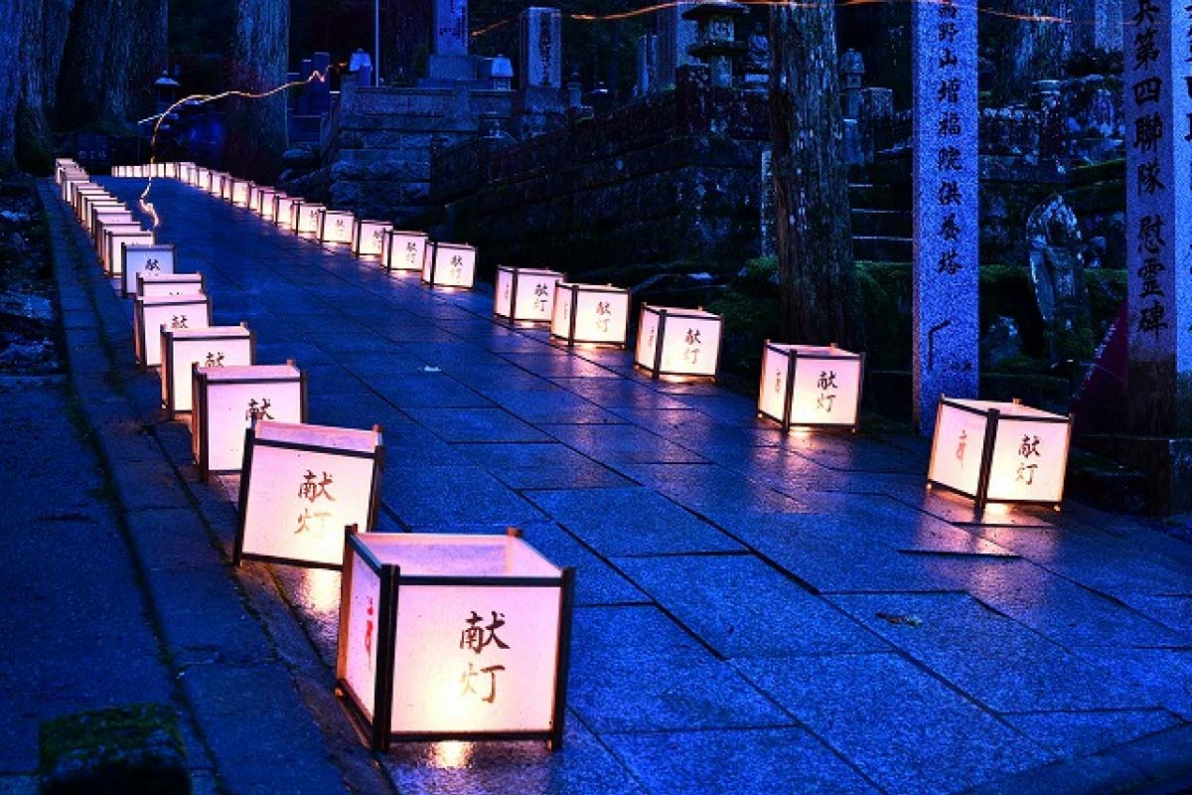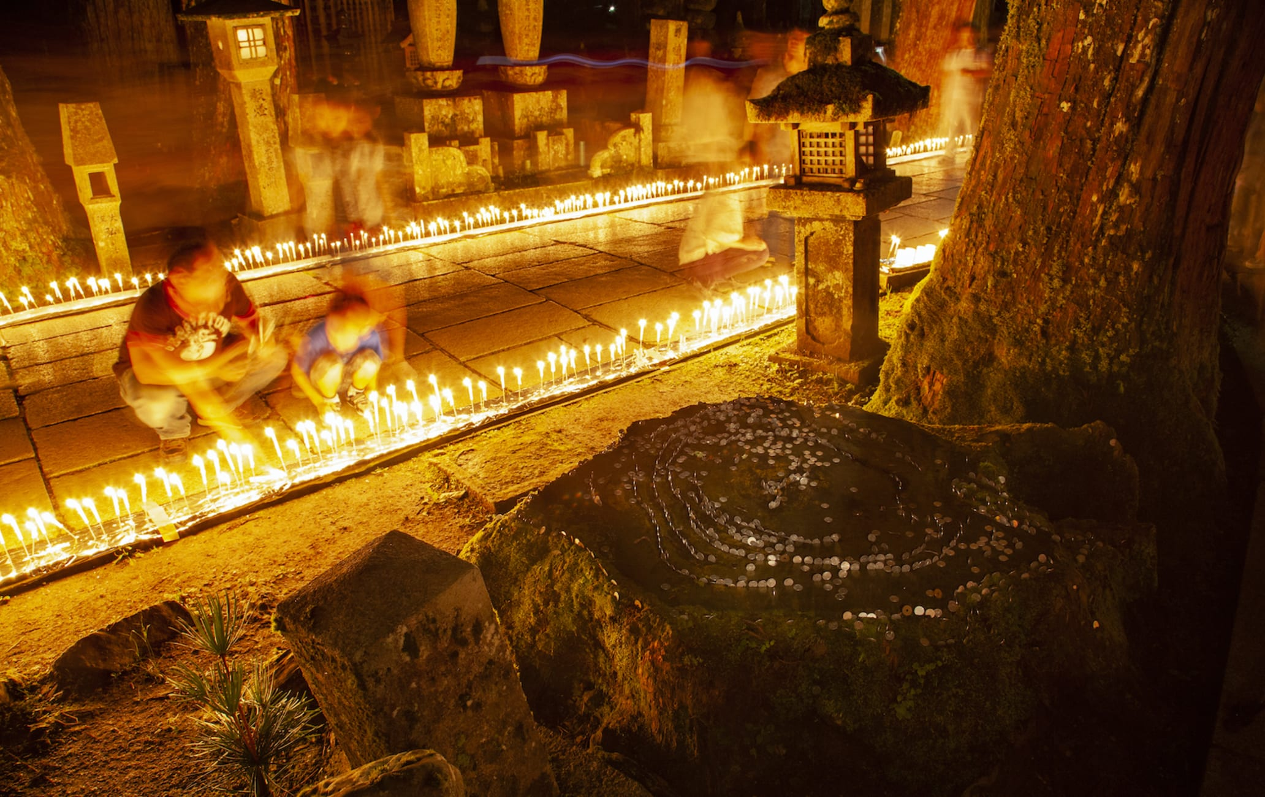Held on August 13th.- Obon is a time when welcoming fires, known as mukaebi, are lit in front of houses to guide ancestral spirits back home. Mandokuyoe Candle Festival on Mount Koya creates a different spiritual sphere. On August 13, the walk up to sacred Okunoin Temple is illuminated by the flickering flames of around 100,000 candles directing souls back to where they reside.Candles are placed from the Ichinohashi Bridge, the entrance to the sacred area, and all along the pilgrim’s road. Follow along the pale floating path in darkness to a ceremony at Torodo Hall to commemorate all who rest at this ancient religious site.